**Jenkins Hands-On:**

**Create a pipeline project to build java application and deploy into tomcat container**

**Pipeline Script:**

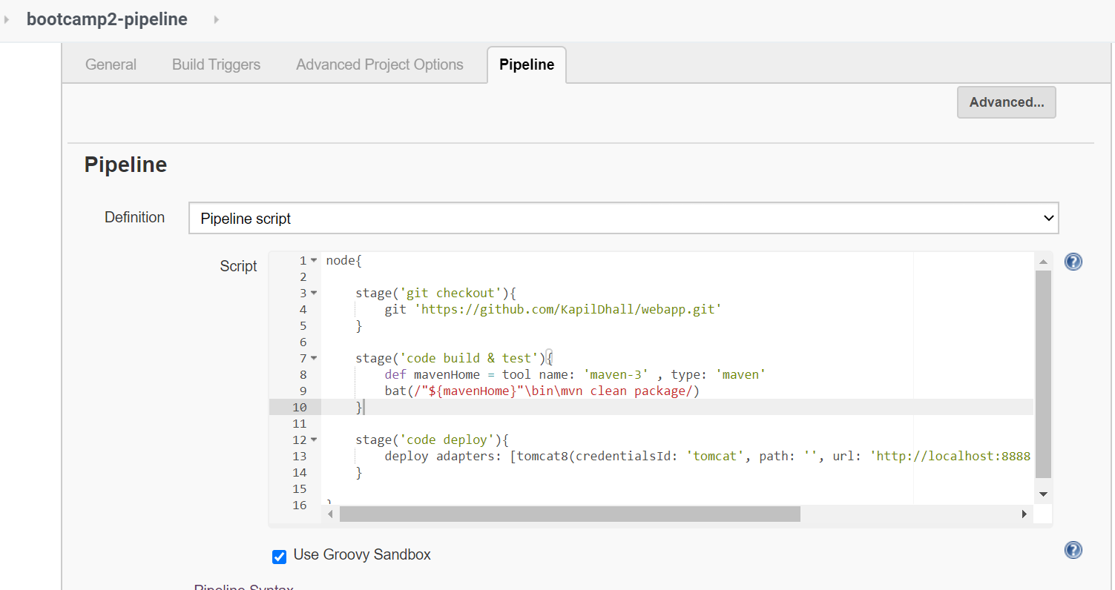

**Jenkinsfile:**

*node{*

*stage('git checkout'){*

*git 'https://github.com/KapilDhall/webapp.git'*

*}*

*stage('code build & test'){*

*def mavenHome = tool name: 'maven-3' , type: 'maven'*

*bat(/"${mavenHome}"\bin\mvn clean package/)*

*}*

*stage('code deploy'){*

*deploy adapters: [tomcat8(credentialsId: 'tomcat', path: '', url: 'http://localhost:8888')], contextPath: 'pipeline', war: '**/*.war'*

*}*

*}*

**Console Output:**

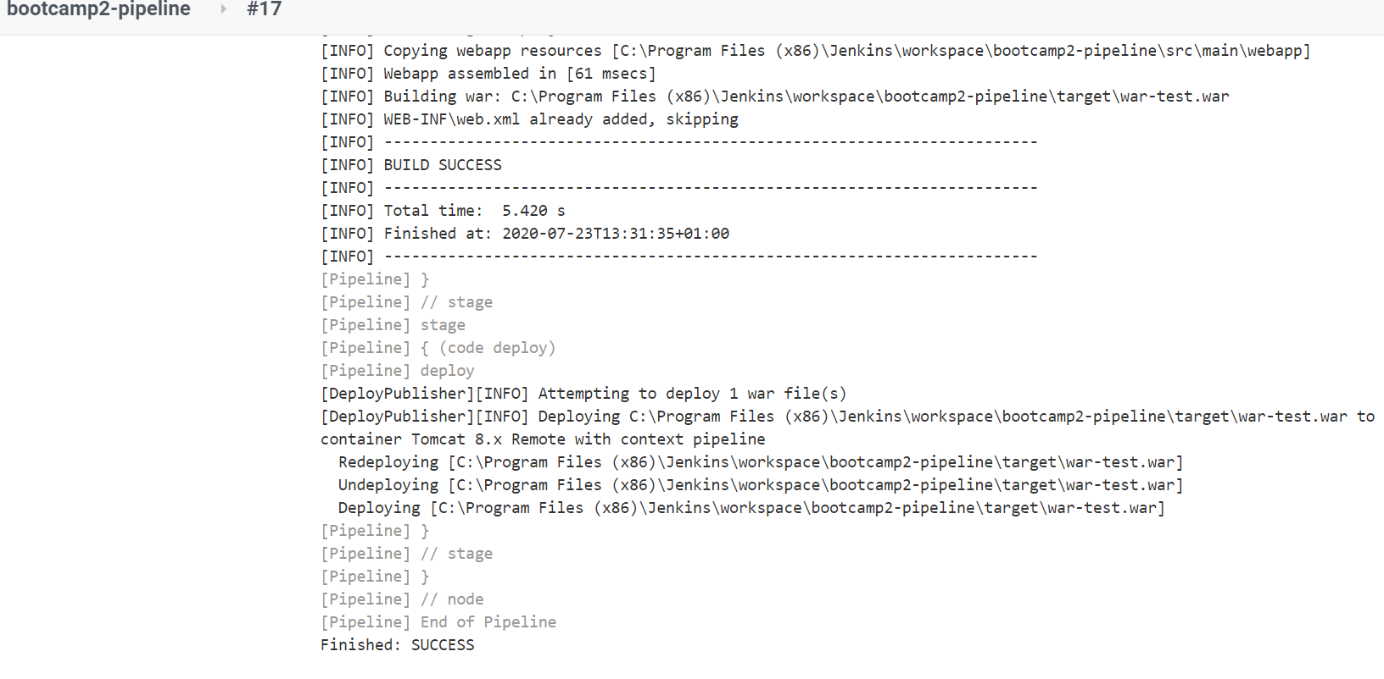

**Build:**

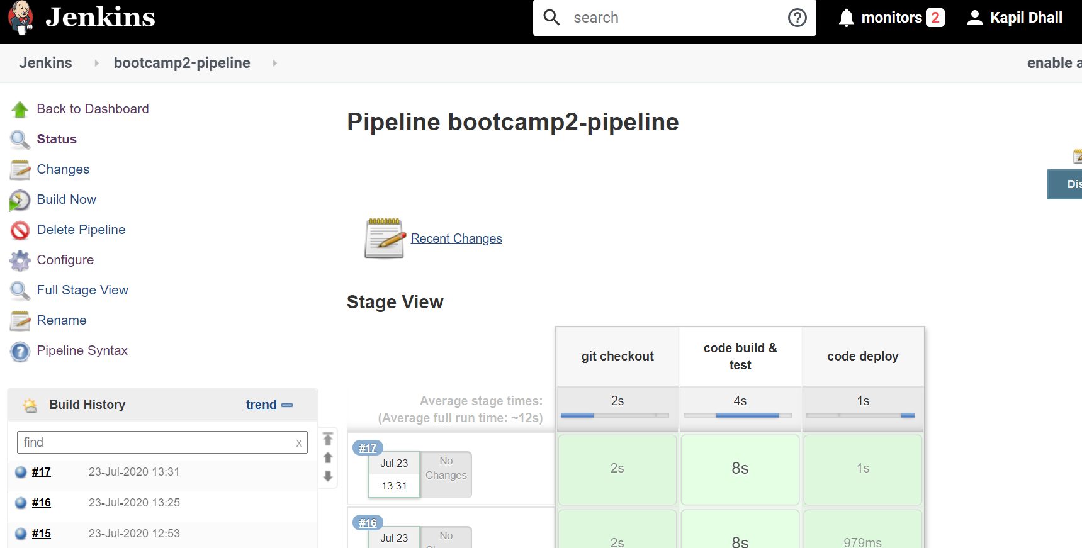

**Verify using url:**

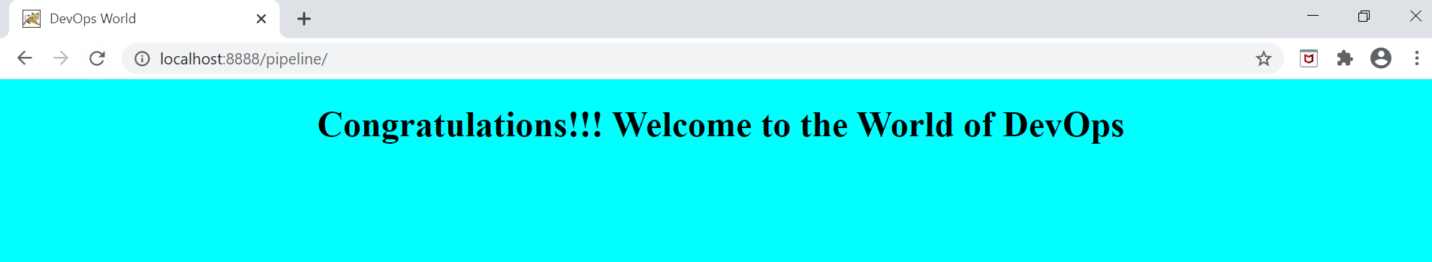

**Create a pipeline project to checkout springboot application using git, build and package using runtime maven, build docker image and push to docker hub and deply into cloud foundry**

**Dockerfile:**

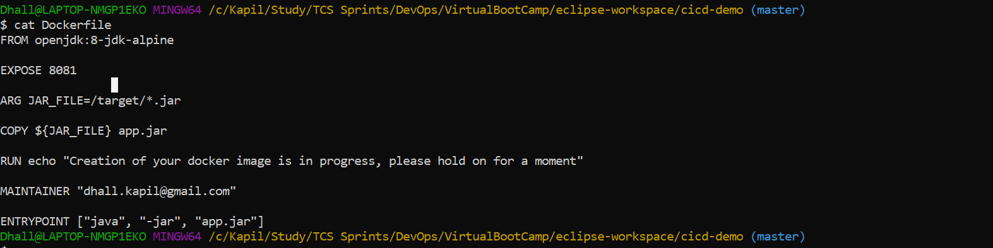

**Jenkinsfile (this file is also placed manually at root location of https://github.com/KapilDhall/DevOps.git):**

*node{*

*def docker=tool name: 'docker-jenkins', type: 'dockerTool'*

*def dockerCMD = "$docker/bin/docker"*

*stage('git checkout'){*

*git 'https://github.com/KapilDhall/DevOps.git'*

*}*

*stage('code build & test'){*

*def mavenHome = tool name: 'maven-3' , type: 'maven'*

*sh "${mavenHome}/bin/mvn clean package"*

*}*

*stage('docker build'){*

*sh "$dockerCMD build -t dhallk/cicd-demo:4.0 ."*

*}*

*stage('docker push to docker hub'){*

*withCredentials([string(credentialsId: 'dockerhub-pwd', variable: 'dockerhub_pwd')]) {*

*sh "$dockerCMD login -u dhallk -p $dockerhub_pwd"*

*}*

*sh "$dockerCMD push dhallk/cicd-demo:4.0"*

*}*

*stage('docker image deploy to cloud foundry'){*

*withCredentials([string(credentialsId: 'pcf_pwd', variable: 'pcf_pwd')]) {*

*// some block*

*sh "cf login -a https://api.run.pivotal.io -u dhall.kapil@gmail.com -p $pcf_pwd -o KapilDhall -s development"*

*}*

*sh "cf push -t 180 kapildhall_myapp_sb_pcf --docker-image dhallk/cicd-demo:4.0"*

*}*

*}*

*Pipeline Script screenshot is attached below same as mentioned above in Jenkinsfile:*

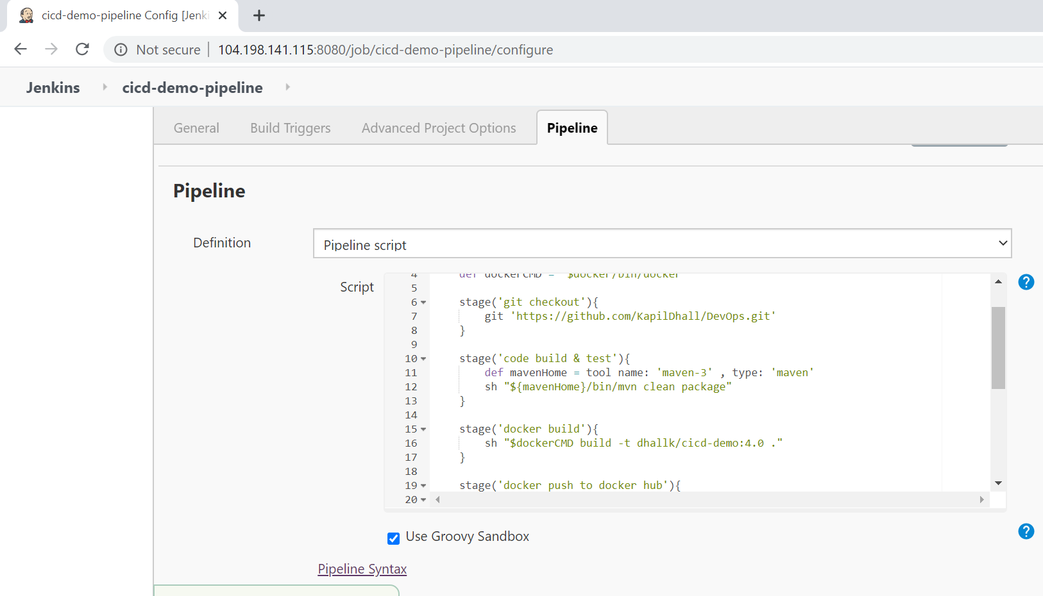

**Build pipeline:**



**Code build and test output stage console output:**

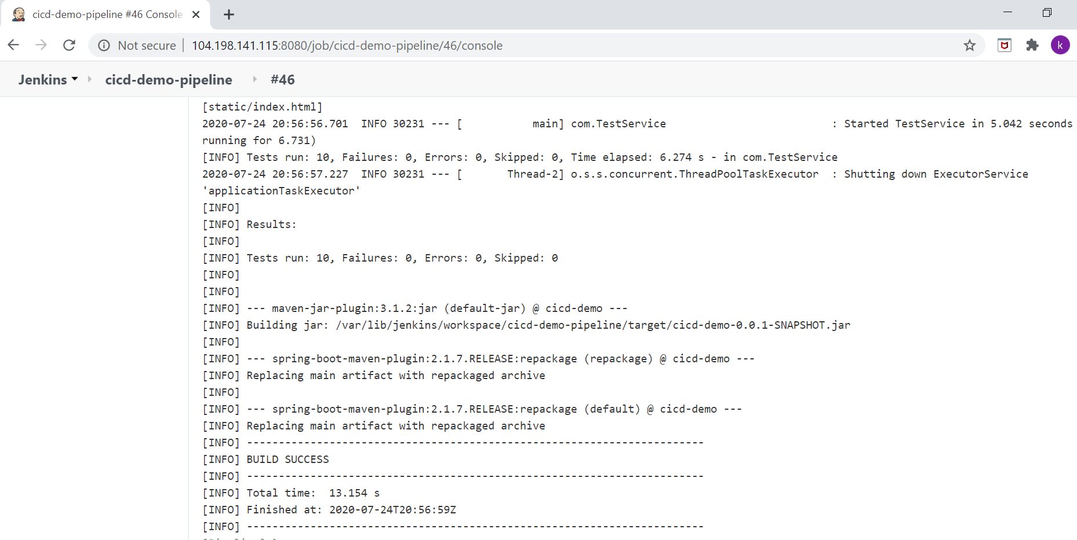

**Docker build console output:**

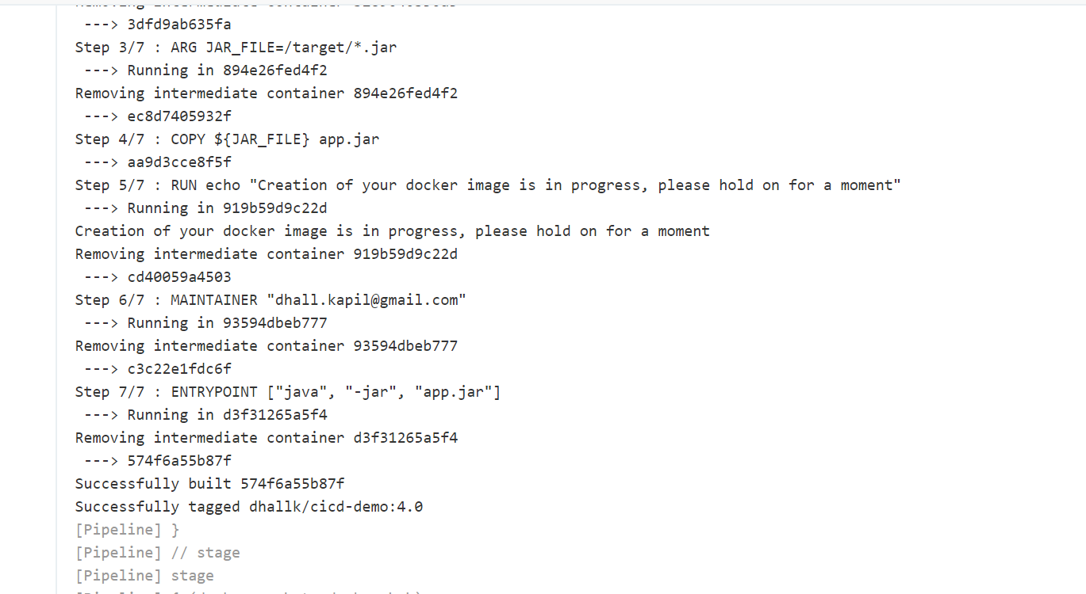

**Docker push to Docker hub console output:**

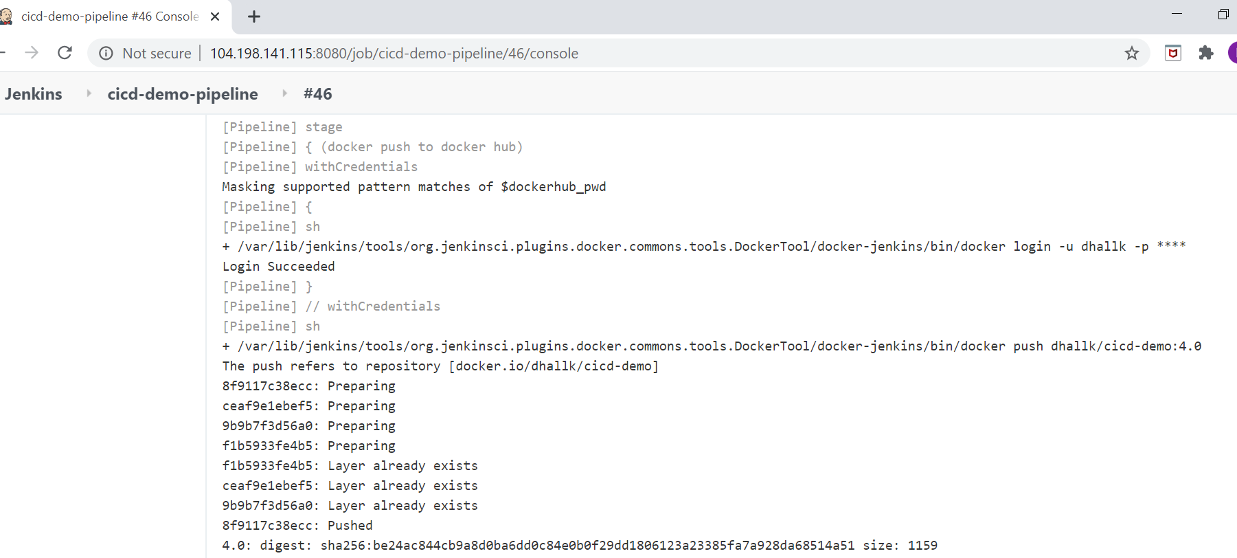

**Docker image deploy to Cloud foundry console output:**

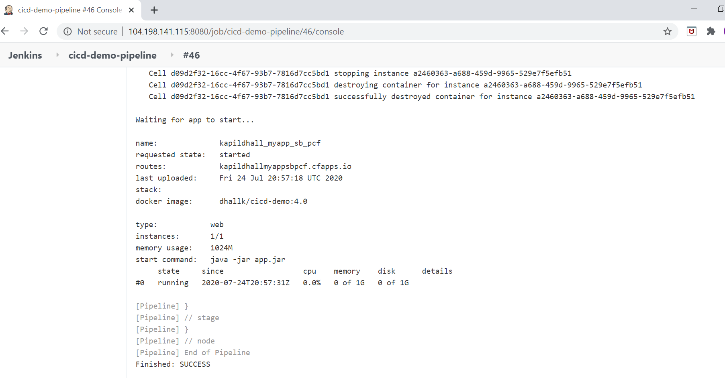

**Verify image on docker hub:**

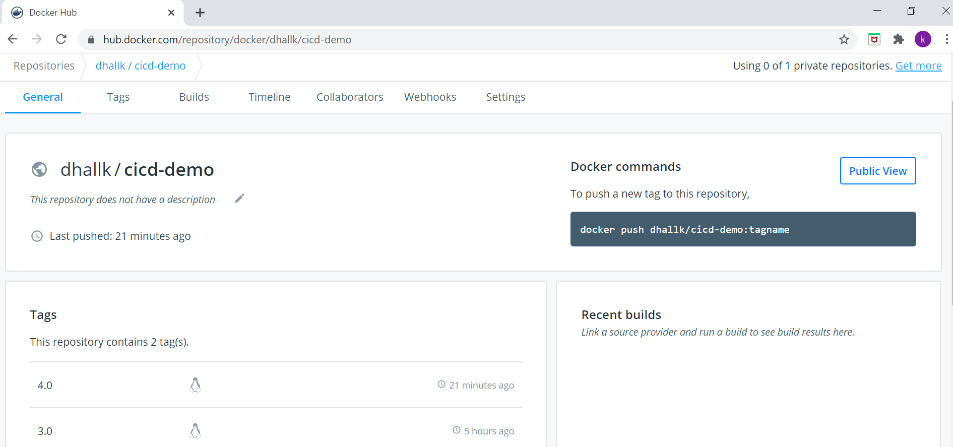

**Verify the application in Cloud Foundry:**

